**Balloon Blaster**

1. Delete Sprite 1 (the cat)
2. Add a variable Score available to all sprites and visible on the stage.
3. Paint a backdrop as a bitmap graphic.

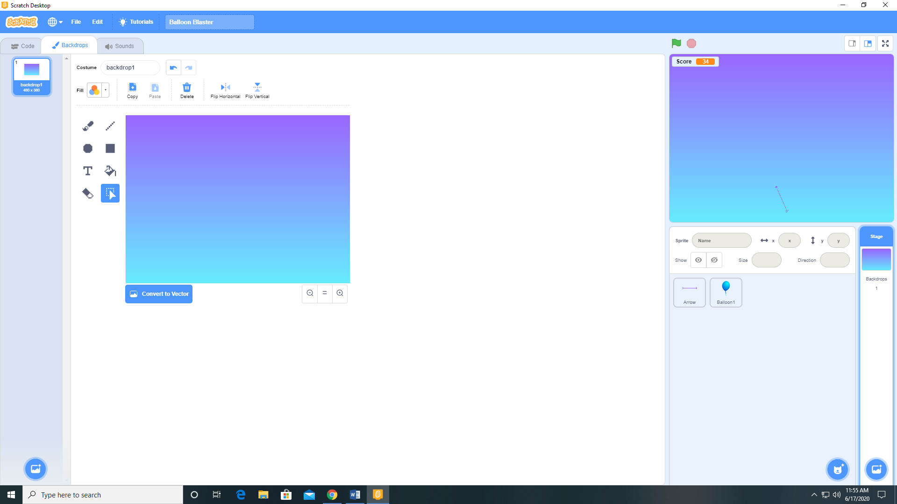

1. Paint a new sprite (Arrow) as a bitmap.

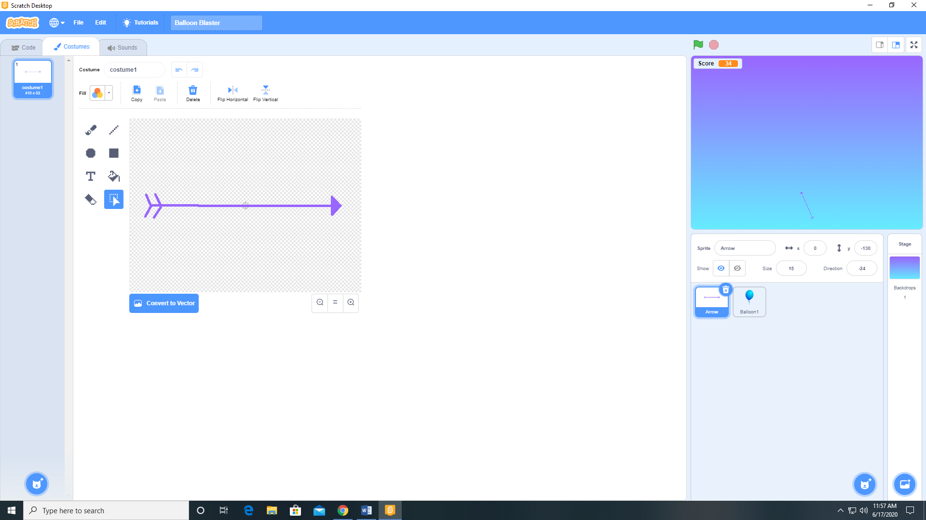

1. Add a sprite from the sprite library (Balloon 1).
2. With the Arrow sprite selected add Boing from the sounds library.
3. Add the following code to the Arrow sprite.

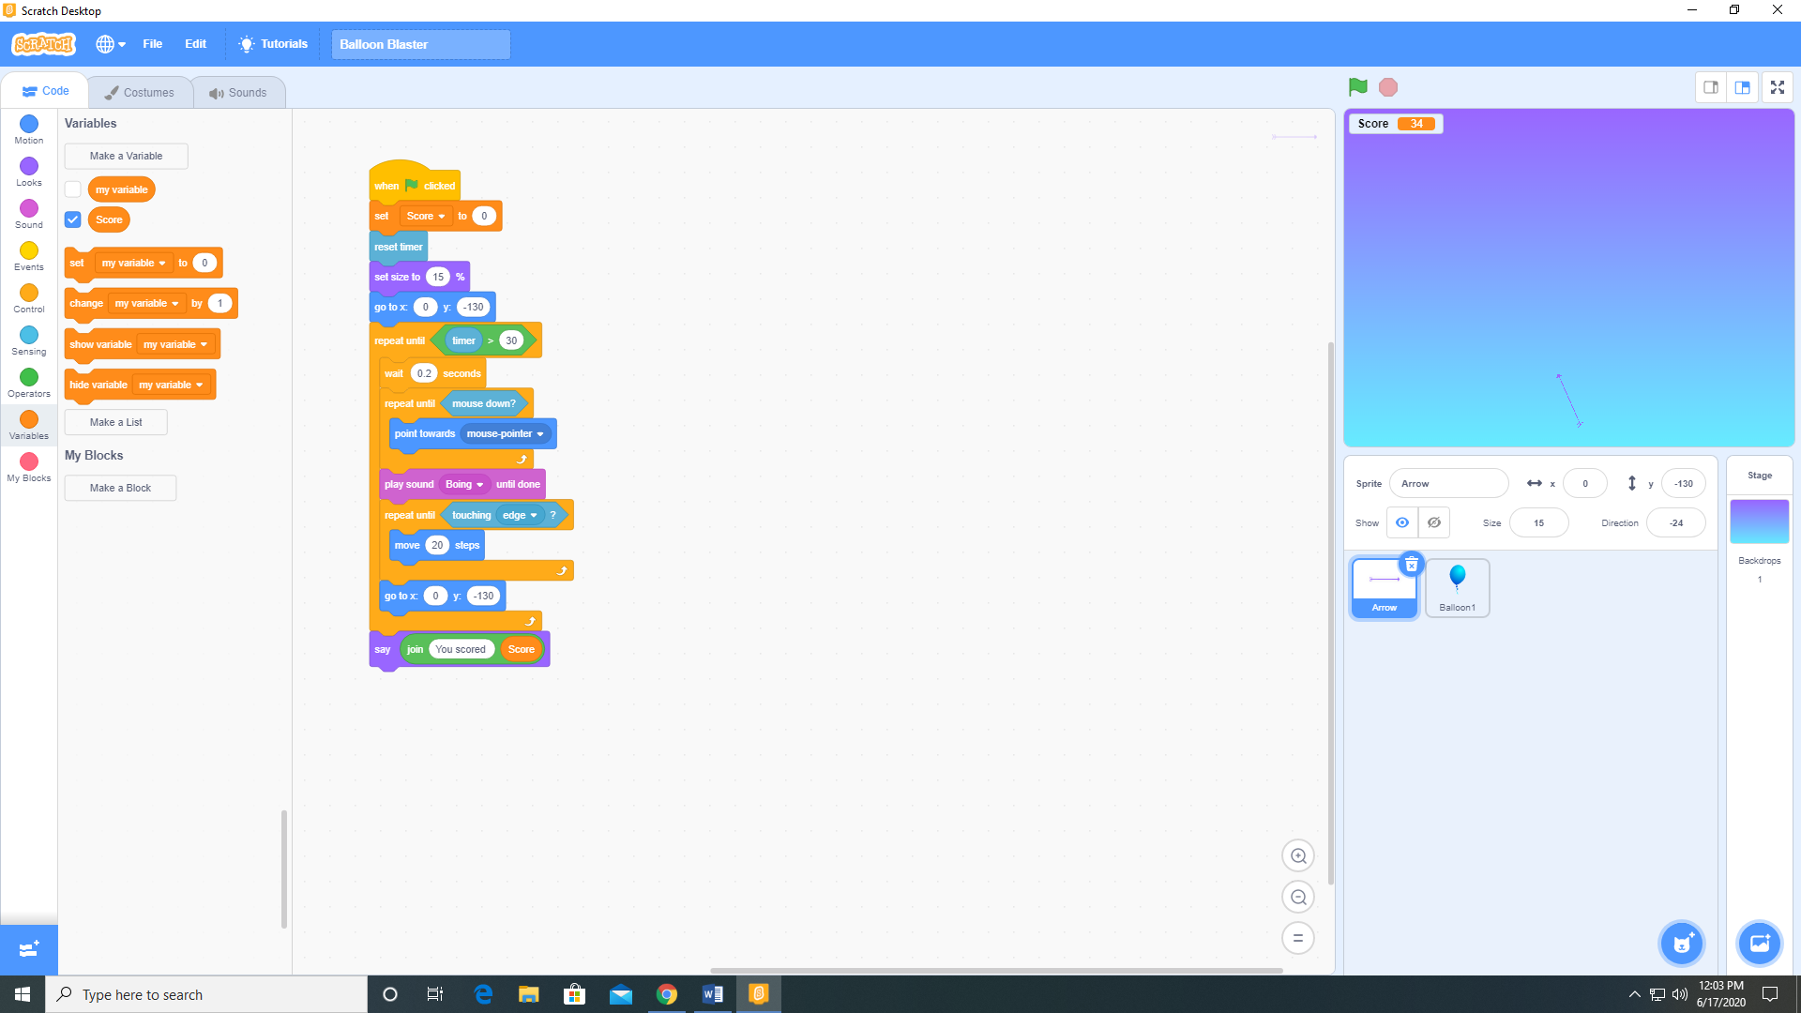

1. Add the following code to the Balloon 1 sprite.

